**Memory Leaks**

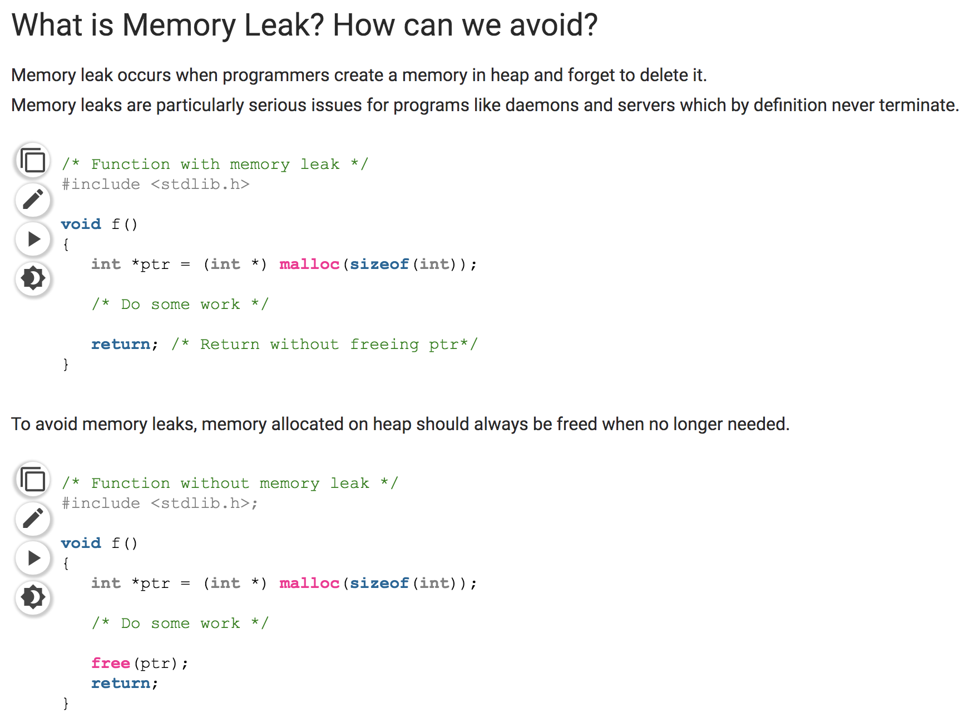

Leaks = whenever you use malloc to allocate memory to something, you have to free it, whenever you’ve moved the pointer:

(g, a, k, u, y) ------> (g) + (a, k, u, y)

The pointer from the original string (g, a, k, u, y), (g) is *now* considered a leak since its holding a place in memory that isn’t being used. The new string (a, k, u, y) should also be freed as well if you allocate memory for it.

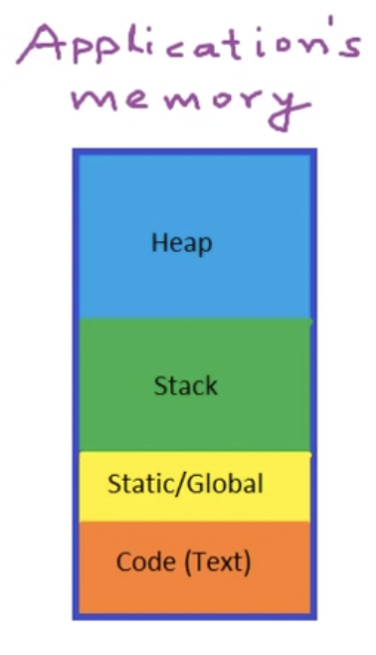

[Reference can be found here.](https://www.geeksforgeeks.org/what-is-memory-leak-how-can-we-avoid/)

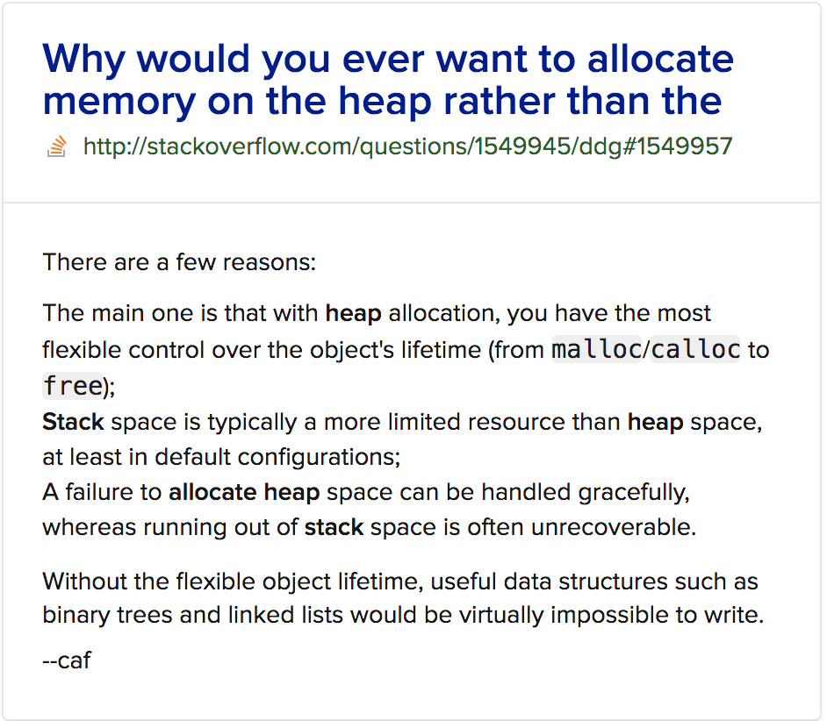

* When we call a function, all the things necessary for function execution go into the **STACK** section of the memory. Anytime a function is called, some amount of memory is allocated for its execution.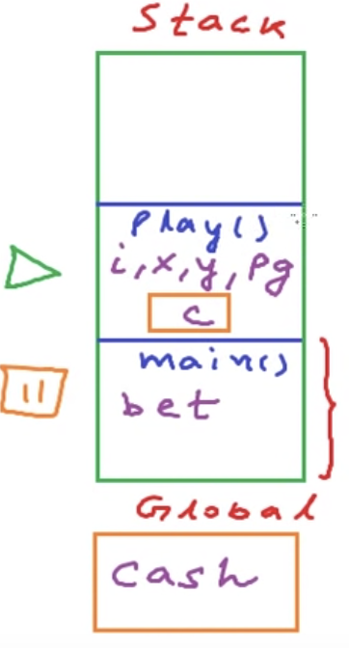
* When a function is called, memory on the stack is allocated and the main function is paused.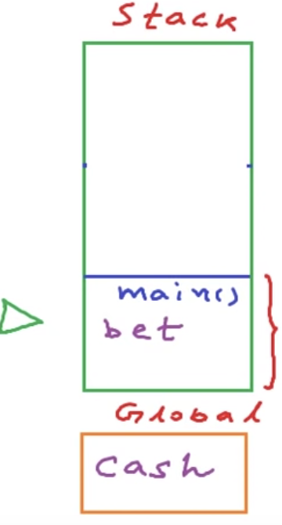
* When the **STACK** function called by main is finished executing, that memory will be reclaimed and the main will continue executing.
* Allocating memory with a call to malloc() will allow you to take advantage of more memory found on the heap for whenever you have dynamic variable values.
* Anything on the heap has to be access through a pointer variable, **you can only** **POINT to things on the heap with a variable in your functions, eg, strings (char *str).**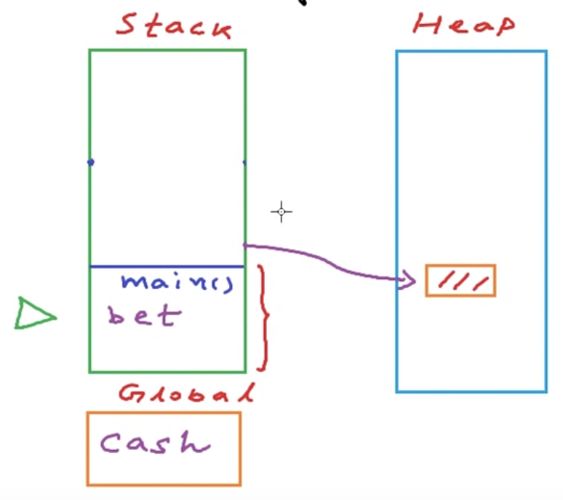
* When the call to the function finishes, all the local variables in the stack will go away but the heap memory will stay unused. **Anything on the heap must be EXPLICITLY DEALLOCATED using the free() function.**
* **Heap** is not fixed in size and our application can claim more memory as long as our system itself is not running out of memory.
* IF we are not deallocating memory we are depleting and wasting memory which is an important resource.
* ***To summarize, memory leaks are an improper use of the heap section of memory that causes our memory usage to increase over time because of unused or unreferenced blocks of memory left on the heap.***

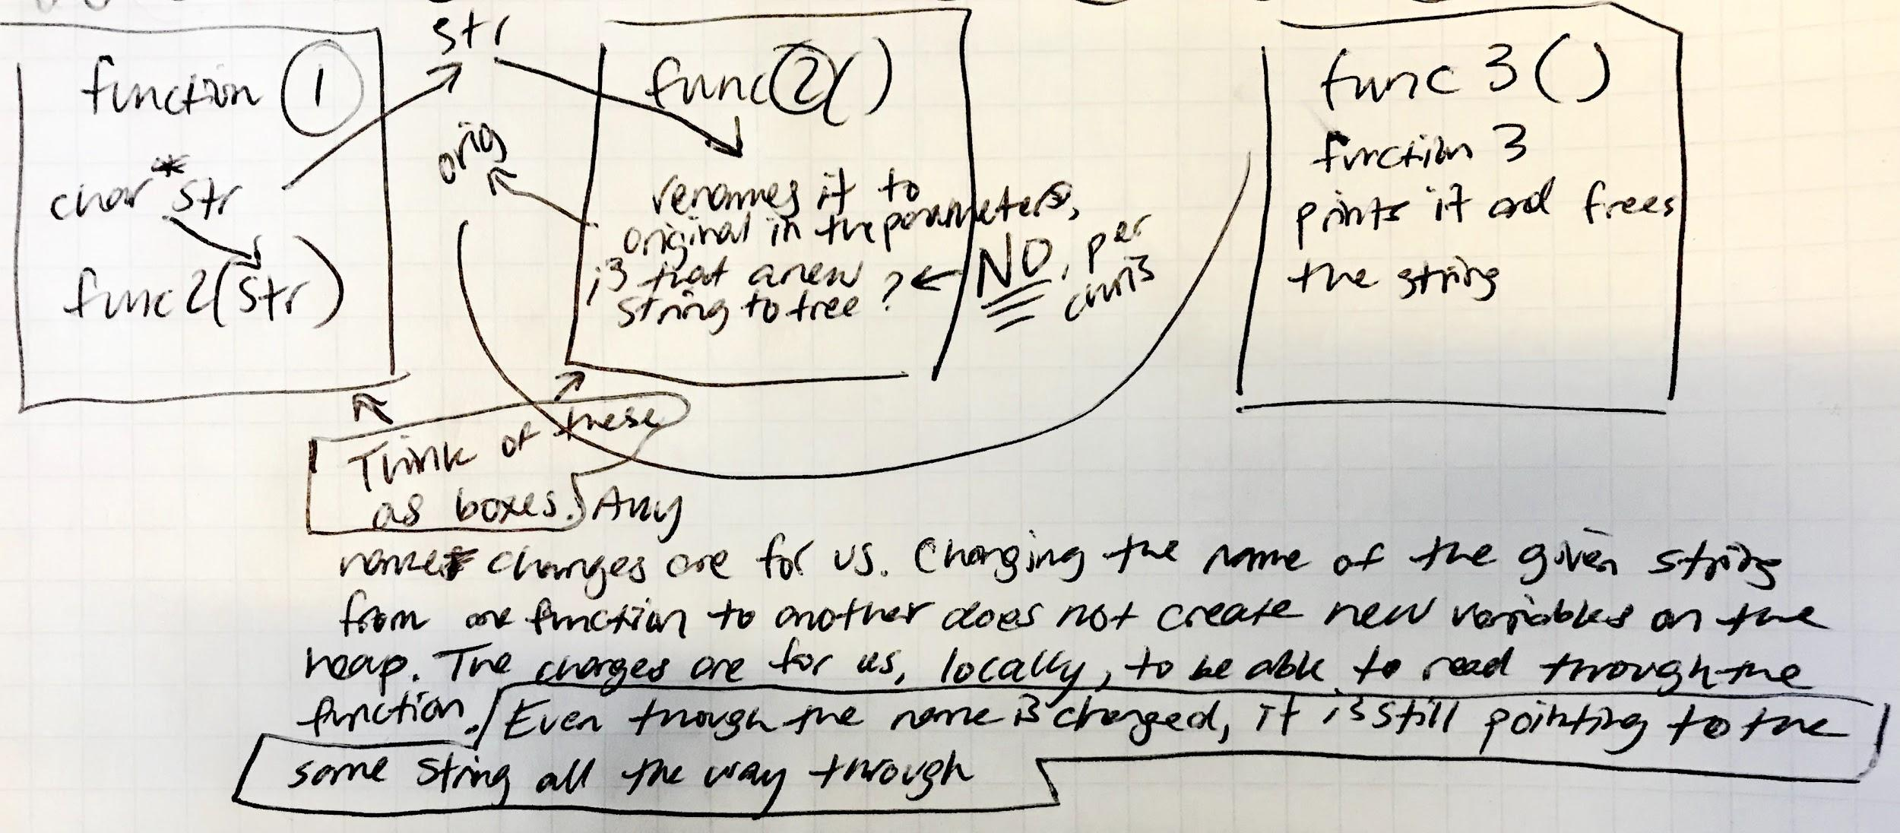

Per Chris about following a string through functions, the name may change locally in those function boxes but they are still pointing to the same place in memory regardless of the string name change.

***You need to be mindful when you’re initializing values using a function that mallocs memory. The return of that function will return a value with a new place in memory. EG

temp = ft_strjoin(temp, origtstr);

The return value initializing *temp*, occupies a **different** place in memory than the given *temp* value parameter in the strjoin function. If you do not free the given *temp* value somewhere in strjoin or outside the function, it will be lost and is a leak. Ask yourself, do I need to malloc in this case? If I do, where is my value being freed?

Elijah’s functions to free memory on his printf:

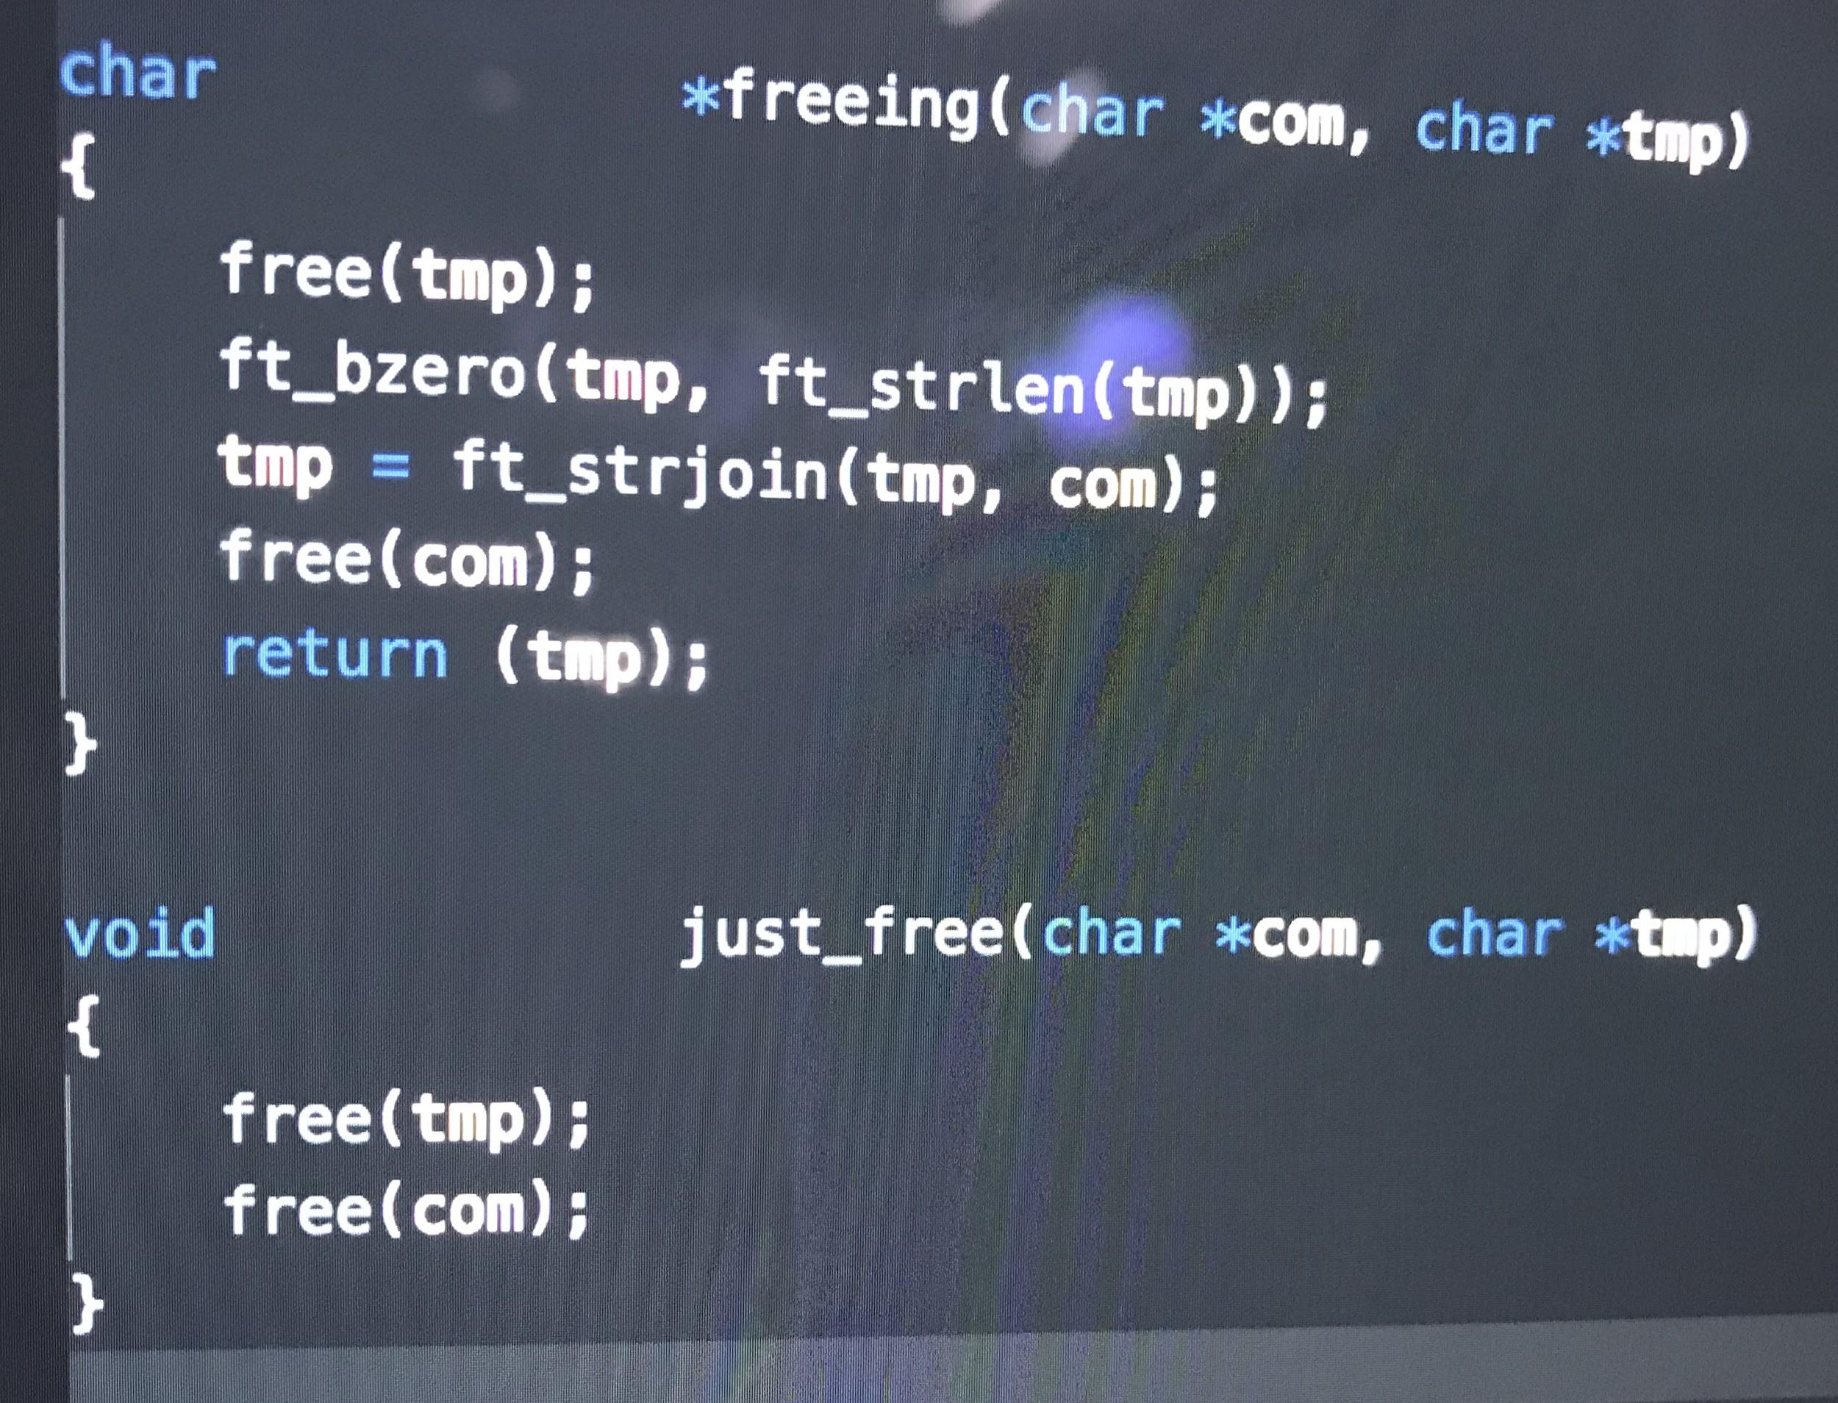

In use:

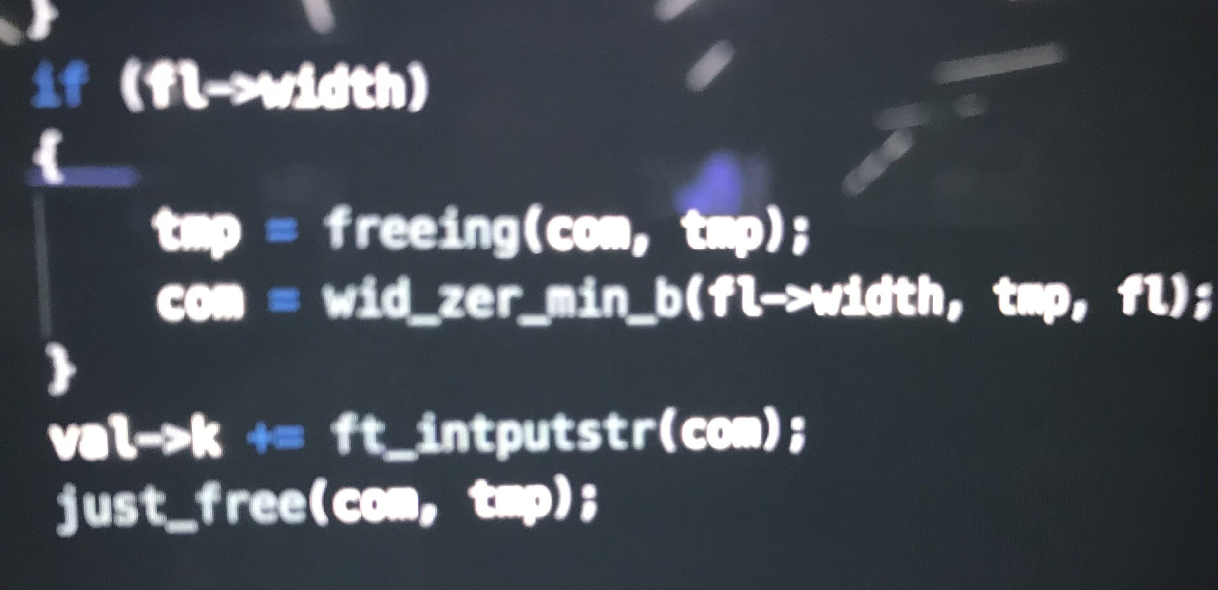

**Valgrind and Leaks**

**Valgrind**

* ***when using valgrind, make sure that you **DO NOT** have **-fsanitize=address** on when compiling the file to run through valgrind.

1. Compile the file using all your required c files. **It will not work when compiling with a library/archive.**
2. Run the command: **valgrind --leak-check=full ./<name of the executable file>**
3. A list will populate that will have your function names in it
4. Go through those blocks and get rid of the leaks
5. **When you don’t see your function names anymore**, you can run the leaks command below to double check that you in fact, do not have any leaks

**Leaks command**

1. Create a main.c file with all your test case lines
2. At the end of the file, add an infinite while(1) loop
3. Compile the program using all your required c files (**It will not work when compiling with a library)**, run the executable
4. When its running, press (ctrl+z) to stop the process
5. Then run the command: leaks <name of the executable file>

When using valgrind to find leaks, head to the line where the memory is allocated for the variable or string. Identify that value/variable/string and try to follow it through your functions.

* Ask yourself:
  + Where is it used?
  + **Follow that string -** What’s its lifecycle till it gets lost/disconnected (leak)
* Where is new memory allocated for another variable **using** the leaky value name?
* How can you free it?

[**Function Dispatch Tables in C**](https://blog.alicegoldfuss.com/function-dispatch-tables/)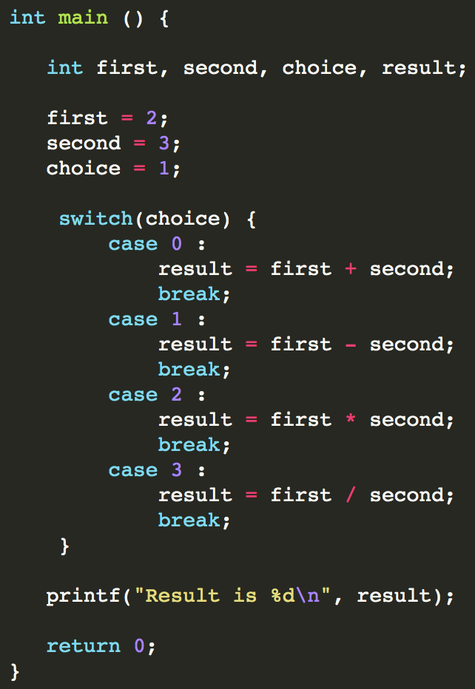

* Branching in programing = if-else statements, this logic flow makes it easy to navigate choices and is found everywhere in every codebase. Some languages have a logic flow called a *case statement (or switch statement)* which cleans up using so many if-else statements.
* Case statements help replace code filled with a lot of if-else statements but sometimes it can be hard to read and if the switch case list had a lot of complicated code, it’d get hard to maintain.
* If there are too many cases, e.g. 100, you would have to go through each of those cases before selecting just one. Case statements are 0(n), where n is the number of case/switch statements possible.
* The last variant of branching is called: a **function dispatch table**.
* **A function dispatch table is an array of function pointers.**
  + A function’s **name** is its address in memory
* You can build an array where the indices point (or *jump*) to the functions assigned to them.



To build a dispatch table:

1. Work from the inside out: **define the function type first**.
2. Look at the functions you’re working with and *abstract* all of them into **one general function does what they *all* do essentially**. You can use along with your general form function name as a template for the dispatch table. (*in the example below, we’re working with addition, subtraction, multiplication and division functions*)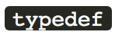



1. Declaring an array of function pointers: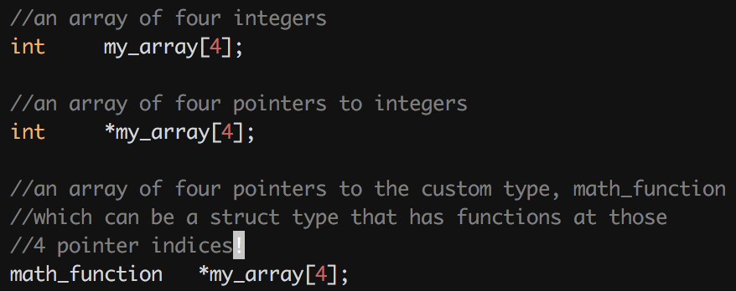

* You can create an array of ints, then think about creating an array of pointers to integers. Once you’ve created an array of pointers to integers, the next step would be to change the type from *int* to ***functions*** as defined in your header file!

1. Once you’ve declared an array with the amount of functions you’ll be placing inside the dispatch table (e.g. math_function *my_array[4] = ), in the following lines, you can list the functions that will be populating the array. You don’t have to provide anything other than the names of the functions as long as they take the same parameters of the same type. *This array creation can be done in your code*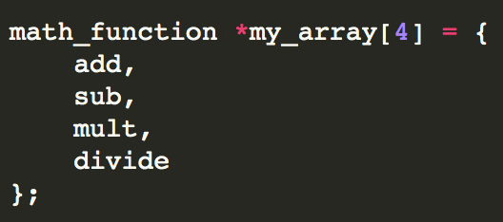
2. You need to prototype all your functions properly in your header file, as well as the generalized typedef function (*that creates the function type for your function array*).
3. When you’re ready to use it, you can use it like this (this is jin’s dispatch table):

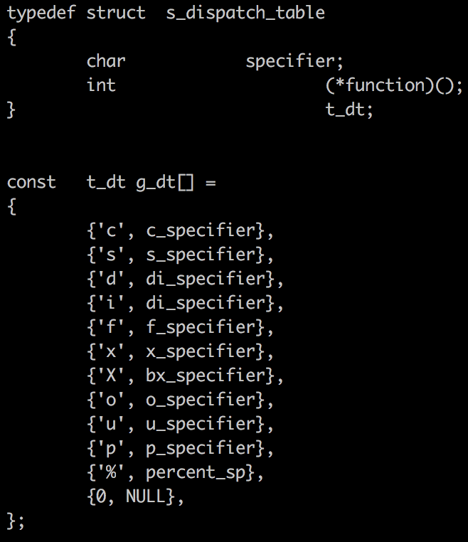

It looks like Jin created a structure to hold the dispatch table itself (*struct s_dispatch_table*). There are members to hold conversion specifiers and a pointer to function (*\*function*)(*empty param*) with a type int for the index of the dispatch table corresponding to each function.

Therefore, g_dt[1] = {‘c’, c_specifier}, from what I can abstract right now.

While g_dt[specifiers++]

if (g_dt[specifiers] == arg.conv)

Result = g_dt[specifiers]

****When implementing my dispatch table, I ran into an error where my global dispatch table variable (*g_dt[]*) was being seen twice, it was saying it was a *duplicated symbol* and then giving me a list of all my .c files that it was appearing in. So I searched for the error and found that I needed to **declare the variable in my header file** but **define/initialize it (give it a value)** **inside the actual .c file** that it was going to be used in. So I placed the whole dispatch table inside my conversion.c file and it worked. Glad I read the StackOverflow comments!

[](https://stackoverflow.com/questions/14763190/duplicate-symbol-error-global-variable#14763214)

*** When norming my header file, I had to take away the typedef for the function type because I kept getting norme error that said, “Error (line 64, col 16): conv_func have not a good prefix.” which I guess was pointing to the *typedef* at teh beginnig of the line. So instead of creating that type I just placed the return type of all my conversion functions, *void*, and a pointer to function (**syntax = (*function)()**) into my dispatch table underneath my conv char member. Lastly, I removed the (&) chars in front of each function in my conversion.c dispatch table so that the while loop was able to point to each function in the list.

[**Big O notation O(n)**](https://en.wikipedia.org/wiki/Big_O_notation)

Time complexity of a program is a simple measurement of how the fast the time taken by the program grows if the input size increases so if the input to the program is (n), the time taken for the program is proportional to (n)

Correction of the program is not the only thing, what’s also important is how your program behaves with larger input sizes. **We should always write programs that behave well with large input sizes.**

Time complexity analysis

Time complexity analysis of an algorithm depends on a number of factors. But the most important is how our program behaves, or the how much the time taken grows with differing inputs.

* We are interested in the rate of growth of time taken with respect to the input

**Floating point value conversion**

How to round off a floating point value to two places. For example, 5.567 should become 5.57 and 5.534 should become 5.53

1. The first step is to [round the float up](https://www.geeksforgeeks.org/rounding-floating-point-number-two-decimal-places-c-c/) to the precision value’s digit place! **Use the precision value** to come up with your multiplier.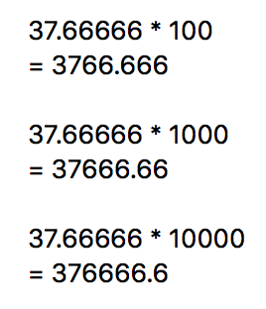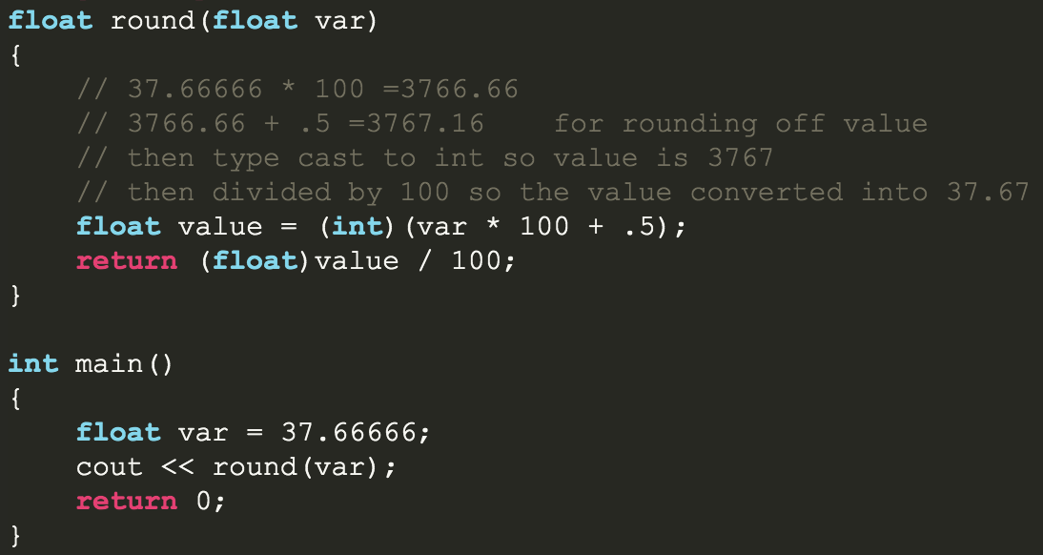
2. **Use a while loop to multiply 1*10 by (x = arg.prec) times to get a multiplier with the proper amount of zeros.**
3. If precision is 2, then you go to the second decimal place  **or, the hundredths place THAT is supposed to be your multiplier.**
4. **Multiplying the initial float value by (100) MOVES the decimal point (2) digits to the right in the new value that you can typecast into an (int).**

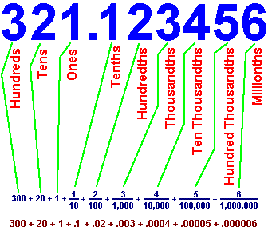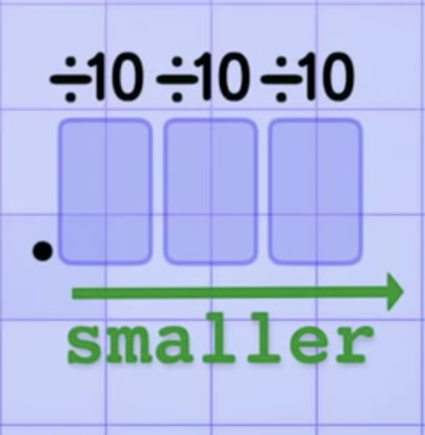

1. Then, to round up the value, add (.5) to the new floating point value
2. Typecast it so that number is an int now
3. Then divide the number **again** by the multiplier
4. **Typecast that value back to a float and return it**

* All the stuff above may not be correct, the regular printf is returning weird values and numbers are behaving weirdly. [This video](https://www.youtube.com/watch?v=8afbTaA-gOQ) might have some clues as to how to approach the problem.



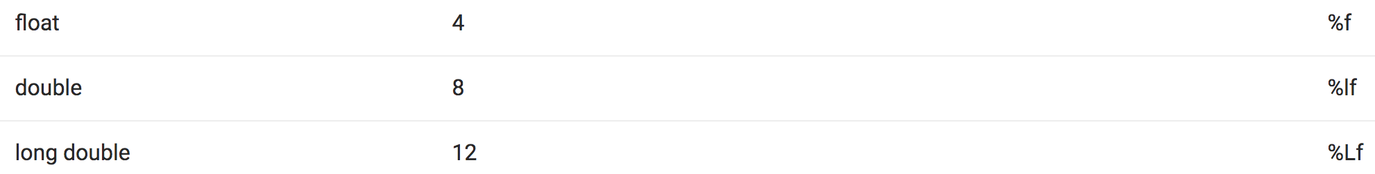

**Data Structures**

A data structure is a way to store and organize data in a computer so that is can be used efficiently.

When we study data structures as ways to organize and store data we talk about them in two ways:

1. **Mathematical/logical models OR Abstract data types (ADTs)** - we just look at an abstract view of them. We look from a high level at all the features and what operations define that particular data structure.
   1. For example:
      1. The abstract view of a television is that its an electrical device that:

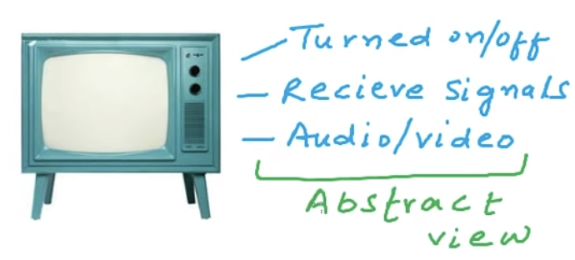

1. **Implementation** - We can refer to data structures by their implementations (eg, linked lists are data structures while stacks are one example of an implementation).
   1. Arrays are data types with concrete implementation
   2. Abstract data types define data and operations, but not implementation of those data types

Lists as abstract data types

* **Lists are collections of objects of the same type**
* We can have a list of word, numbers, names
  + **Arrays are data structures** that give us an **implementation for the abstract data type, lists**

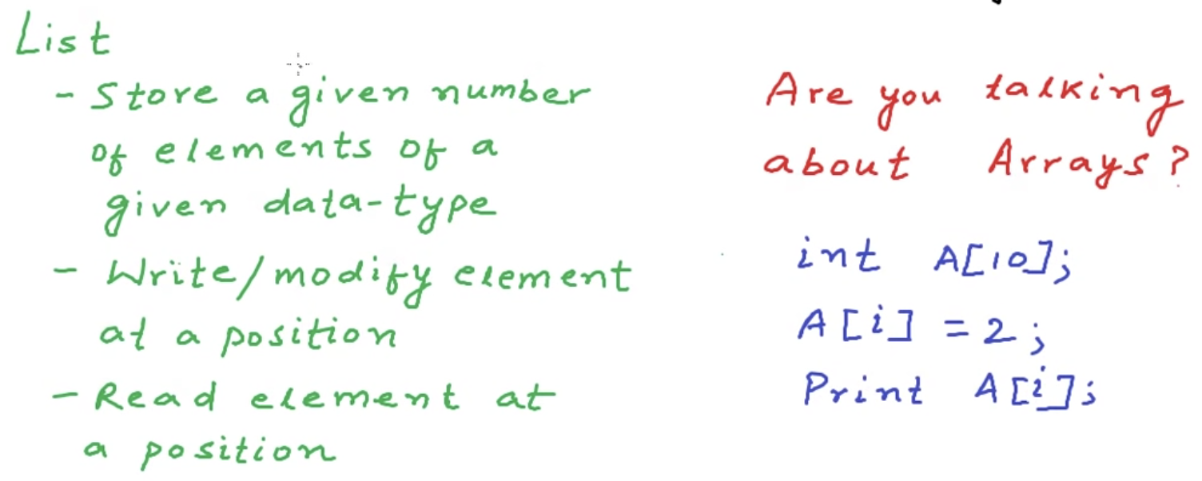

**A stack -** is another abstract data type (**a way of THINKING/VISUALIZING a data type**) that uses a link list data structure in its implementation.

**Linked Lists**

Arrays are contiguous blocks of memory. You know where a particular element is in the array by calculating its address by using the starting address of the block of memory and the position of the element in the array.

**Int A[4]; =**

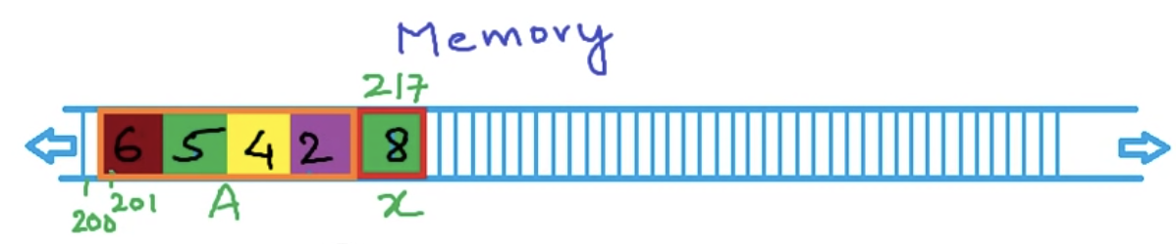

Arrays in memory are static, whenever you want to add data to them that surpasses the bounds of the memory you have allocated, you have to allocate more memory for a new array and then copy the contents of the first array into the new one.

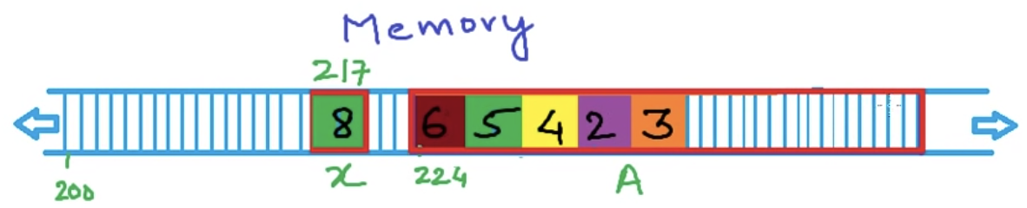

That takes time. And even then, you still aren’t able to dynamically populate the array whenever you have to add more data to that larger array. Sometimes you’re allocating more memory than you actually need, which is not good developer practice. The process begins again.

By making separate requests to non-contiguous blocks of memory, with ***two parts per*** ***block***, we can store the data, or the value, in the first block and then, in the second block, we can store the **address** of the next block in our non-contiguous array.

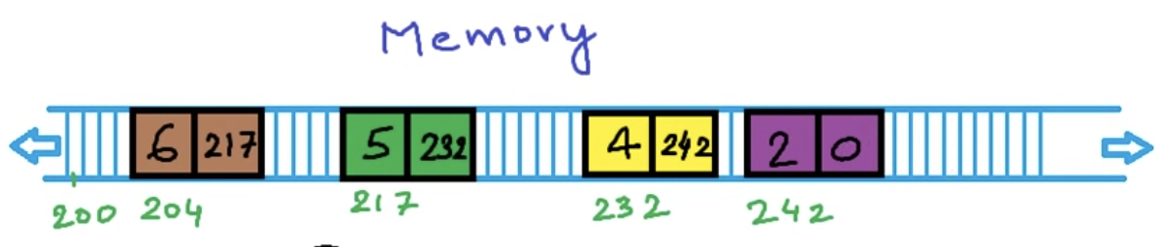

Moving forward, whenever we need to request memory for these two pieces of data that are working together, we could define a structure of type **node:**

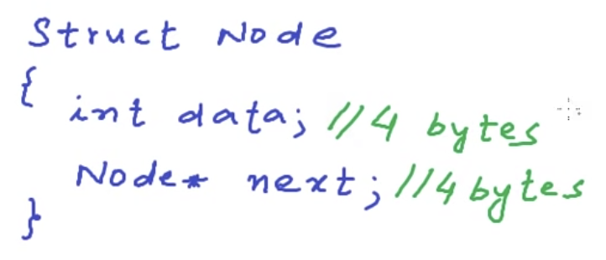

Each time you create a node, you will be requesting memory for an integer called data. That will hold the value from out list. You will also be allocating space for **a pointer called “next” which is of the struct type node**.

In total, this block of memory of struct type node or **“node”** will take up 8 bytes of memory.

**When we store a list in memory as non-contiguous blocks of memory, or “nodes”, connected to each other, this is called a linked list data structure.**

Each node stores the data as well as the link to each other node. The first node is called the **head** node. The only information about the list that is kept all the time is the address of the head node. That gives us access to the complete list, just like the base address of a string.

The address in the last node is **null, or (0).** It does not point to any other node in the list so it is considered the last node.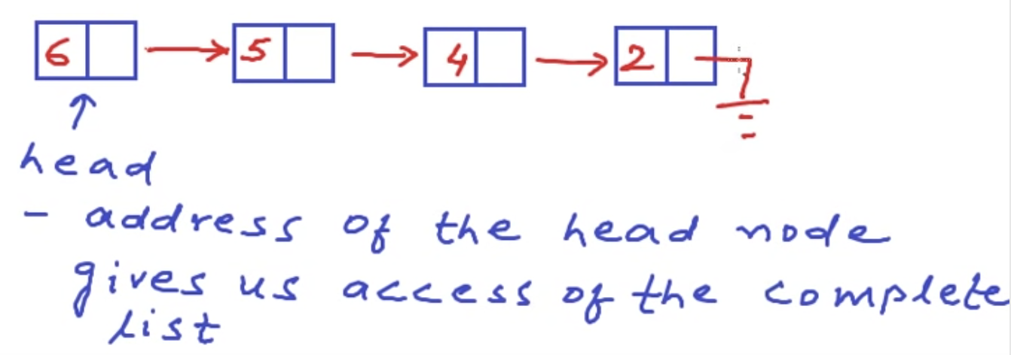

The only way to traverse a linked list is to start at the head and ask each node for the address to the next node and so on down the line till we get to the data we’d like to access, just like looping through a string. You must loop through the linked list.

**Unlike arrays, we cannot access any of the elements in constant time.** With linked lists, we have to start at the head and ask the nodes for the addresses to the next node.

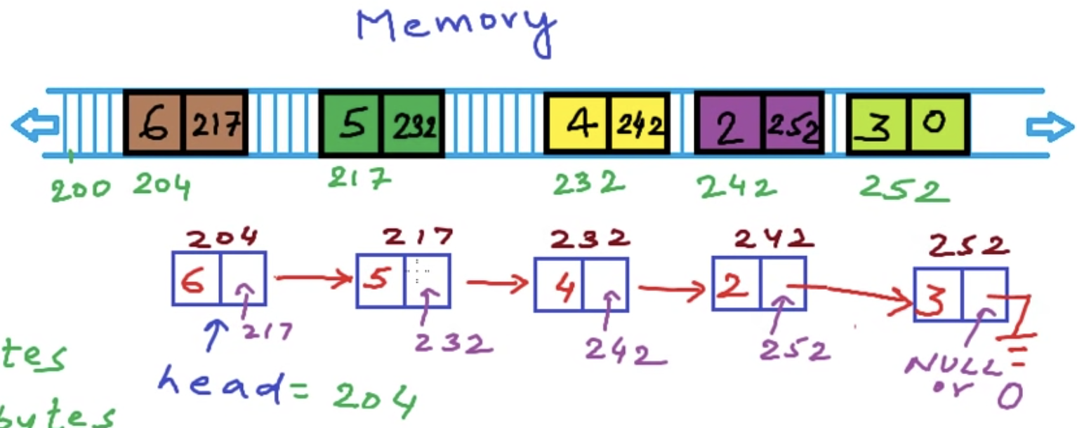

The time complexity of this operation is Big O of N

**Pros of linked lists:**

1. There is no extra use of memory, we create nodes whenever we want and free them whenever they’re not needed.
2. We don’t have to guess the size of the list beforehand like we do with arrays

When comparing linked lists to arrays:

1. Cost of accessing an element

Arrays are great when you need to access an element because of its contiguous layout in memory. If you have a requirement of wanting to be able to access elements of a list all the time, you’d want to use an array. The time complexity to access elements of an array is O(1) while, for a linked list, the time complexity is O(n) (since you always have to start at the head node and loop through the whole list whenever you need to access an element.

1. Memory requirements

With an array, it is of fixed size. We usually try to allocate more memory than we need in case we want to add elements to the array. However, that is not good practice. With a linked list, we only need to allocate memory we need. However, within the data structure, we are actually using a tiny bit more memory for the pointer portion of the node. Adding elements to an array means we have to create a new array and copy over the elements from the old into the new.

1. The cost of inserting an element into an array
   1. Insert something at the beginning of the list
      1. With **arrays,** we would have to shift each element by one position towards the higher index. The time taken will be proportional to the size of the list so the time taken will be O(n), (n) being the size of the list
      2. With **linked lists** all you’d have to do is create a new node and adjust the head pointer and the link of this new node. The time taken does **not** depend of the size of the list, it will be constant. Inserting an element at the beginning of the list is O(1).
   2. Insert something at the end of a list
      1. If an **array** is not full, we just add the element at the end O(1). If its full, we’ll have to create a new array and then copy over all the content O(n).
      2. With a **linked list**, we’d have to traverse the list till we got to the end, create a new node and then adjust all the pointers O(n) where n is the number of elements in the list.
2. Ease of use
   1. Arrays are definitely easier to use
   2. Linked lists are prone to segfaults and memory leaks, it takes some time with work with linked lists.

**Hexadecimal to Decimal number Conversion**

[This video has a pretty good explanation!](https://www.youtube.com/watch?v=pg-HEGBpCQk)

Decimal number system is a base 10 system

Hexadecimal is a base 16 system

**6 (hexa) + 10 (decimal) = hexadecimal**

Counting up towards 10, once you get to 10 in hexadecimal, 10 in hexa is A, 11 is B, etc… up to 15 which is f.

**Endianness**

The issue around endianness:

How does your computer store values that are bigger than one byte in memory when memory is made up of 8 bit locations where we can store 8 bits?

How do we map a 32 bit value? A 64 bit value? A 16 bit value into those locations?

[Computerphile](https://www.youtube.com/watch?v=NcaiHcBvDR4) mentions Gulliver’s Travels and a short story where civil war breaks in a town where people disagree on which end of the egg to start eating from; the big end? Or the little end? Those in favor of the big end, were called **big-endians**, the opposite side, in favor of eatting the egg from the little end, were called **little-endians**.

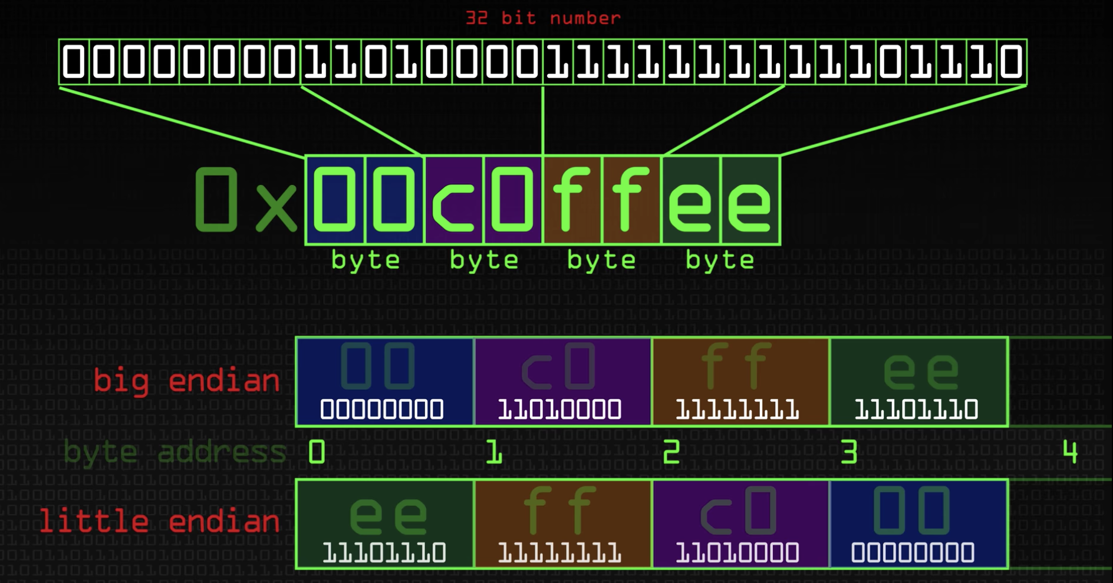

Computers that go by Big-endian sort bits in memory in a familiar way, eg, **left to right (least to most significant bit position)**, from the beginning to the end as humans would read normally. In the screenshot below, the most significant bit position is the 31st bit while the least significant is the 0th bit. Little-endian assigns it bits the opposite way, with bits in the value being laid out from its most significant bit to its least significant. **(See below)**

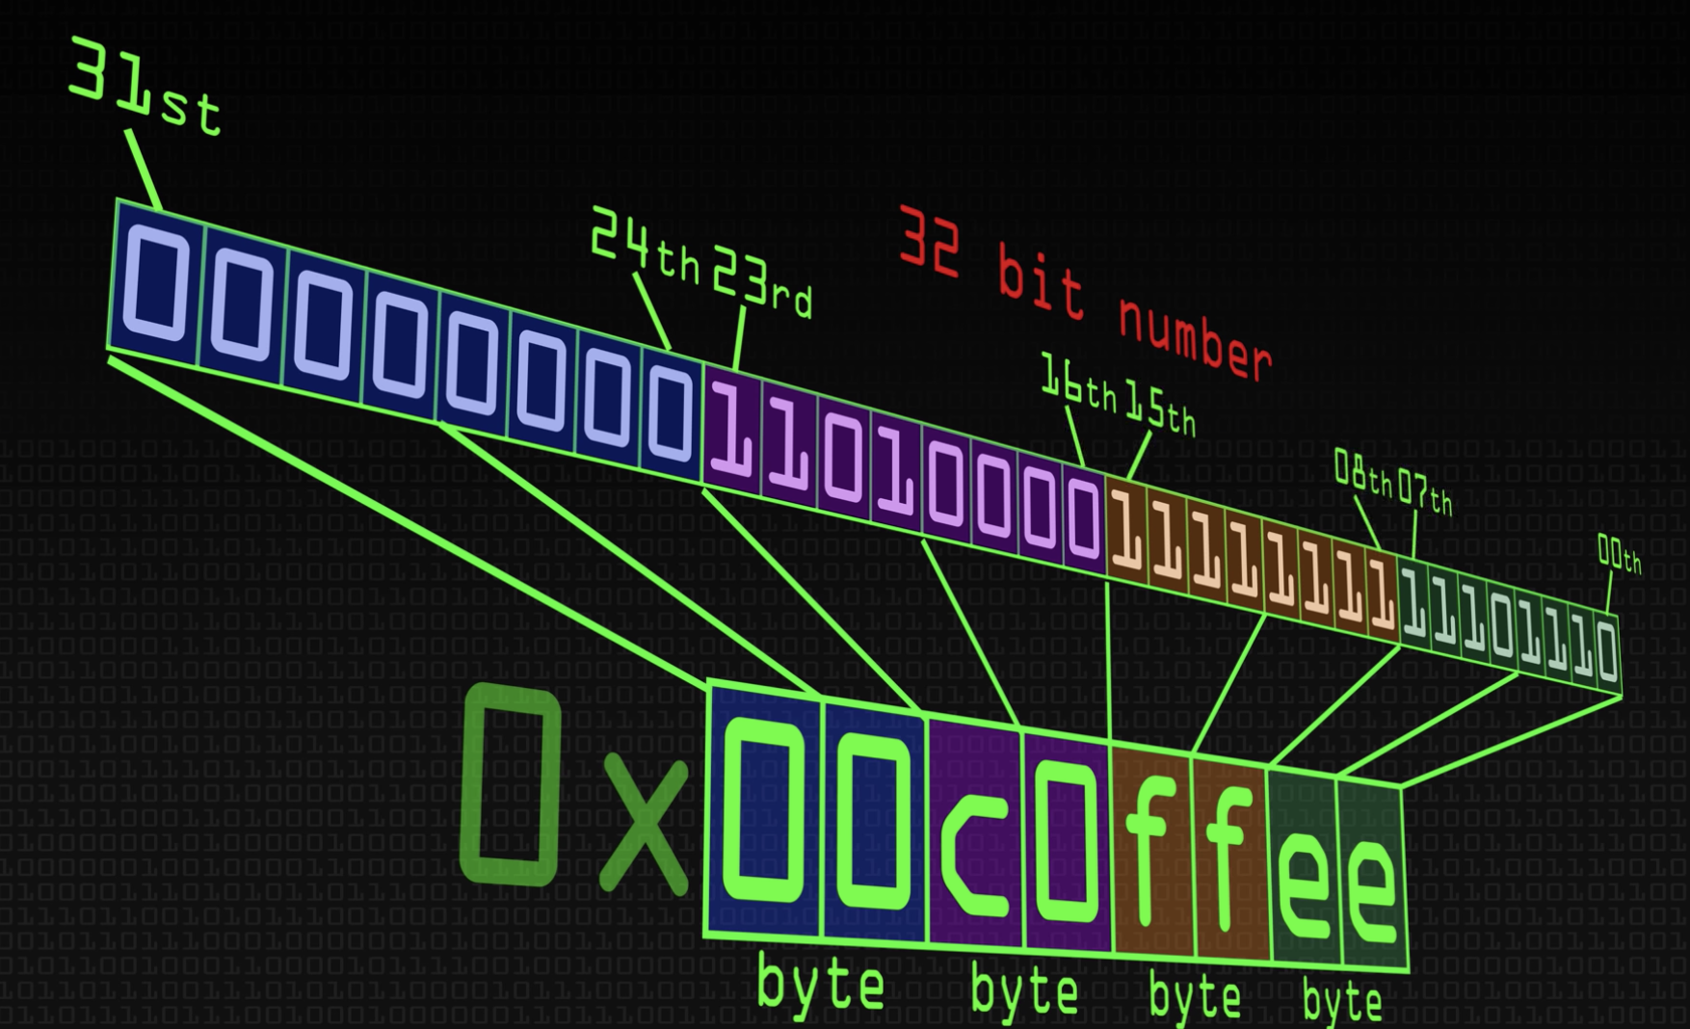

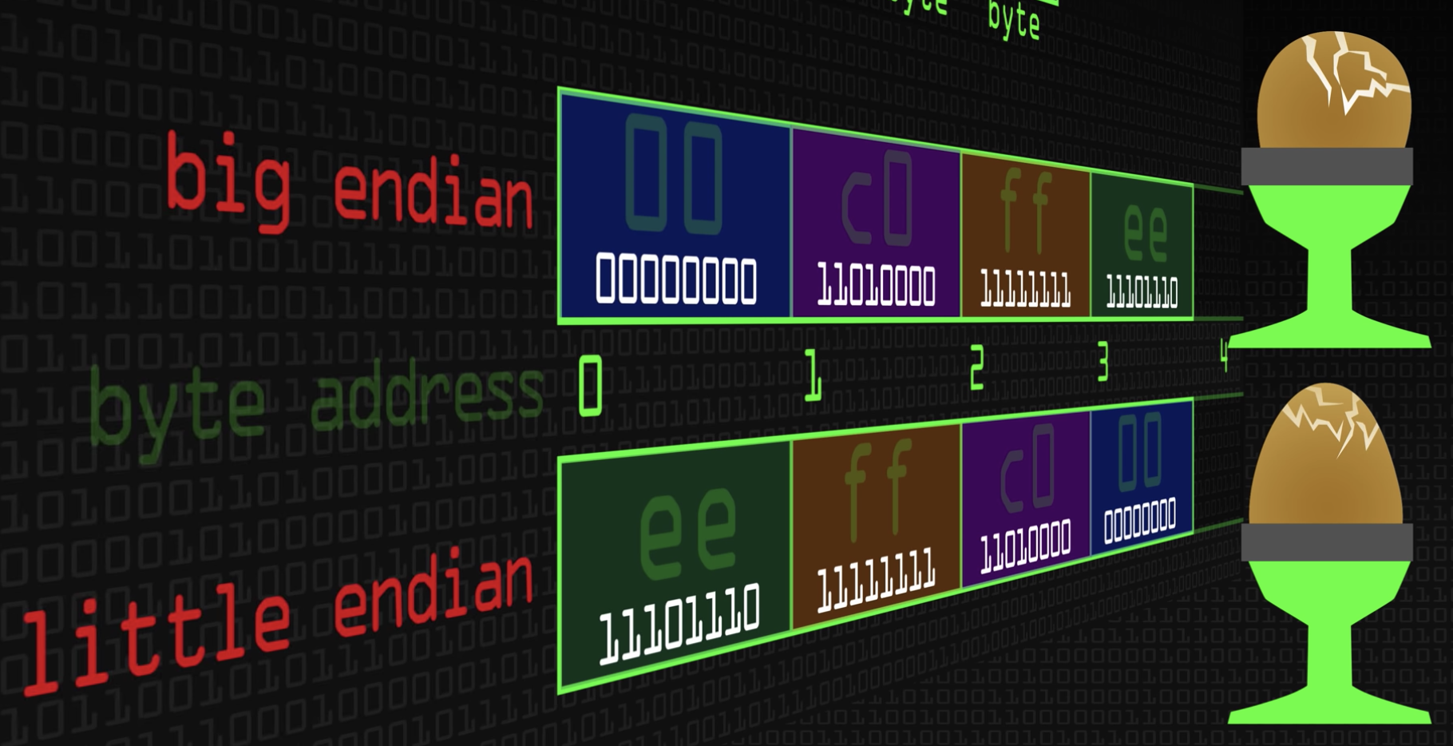A nibble is half a byte (or octet) **=** four bits

**LLDB Instructions:**

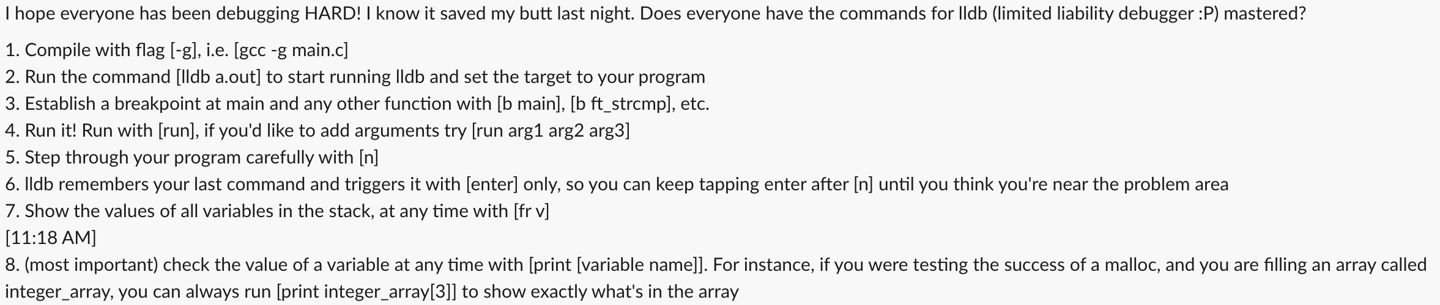

* You can press [gui] after you’ve set a breakpoint and run the program to go into the gui for LLDB.
  + Pressing [escape] **once** will exit the LLDB gui
* You can also step into a function with [s] whenever the blue bar is highlighting a function.
* Pressing [q] **once** will exit LLDB and return you to your normal terminal

Check out the screenshot below of the program in action:

